====================================

**Massey Cancer Center**

**Mouse Tracking Application**

**Usage Guide**



====================================

**Table of Contents**

1. Main View – Rack View
   1. Menu
      1. Alerts
      2. Filtering
      3. Scanning QR Codes
      4. Settings
      5. Logout
   2. Refresh View
2. Breeding Cage View
   1. Creating New Breeding Cages
   2. Modifying an Existing Breeding Cage
   3. Adding Litters
   4. Adding/Viewing Males
3. Stock Cage View
   1. Creating New Stock Cages
   2. Modifying an Existing Selling Cage
4. Breeding Male View
   1. Creating New Breeding Males
   2. Modifying Existing Breeding Males
   3. Moving Breeding Males to A New Cage
5. Alerts View
6. Scan QR Code View
7. Settings View

**Main View – Rack View:**

Overview:

This view is structured to represent one face of the racks that hold the cages where mice are stored in the clean room. Each cell represents a cage which is selectable. Cells display the cage’s row and column information in its upper left-hand corner, i.e.) “1 : 1”. The cells also display any alerts that are currently active on that particular cage in the form of colored dots in the upper right-hand corner. The color of the dots for each alert is selectable in the Settings page (See Settings View section of usage guide). Selecting a cage will display that particular cage’s stored information in the proper view. In addition, to view other rack faces, swipe left or right anywhere on the screen. Note that the rack number indicator in the center at the top of the screen adjusts as you swipe left or right. Make sure that the racks are properly labeled to correspond with the naming convention used in the application, or that you are aware of where the rack face you are viewing in-app is the correct physical rack you are currently manipulating. For example, “Rack View 1” only displays the cages on one face of a physical rack in the clean room. “Rack View 2” would then be the opposite face of the rack the same rack.

Cage Variations:

* *Blue Cages:* Represent cages used for breeding new mice.
* *Green Cages:* Represent cages used for holding mice for sale.
* *Grey Cages:* These are unused cells. New cages can be created here by tapping on the grey cell.

Menu:

The menu button is located in the top left of the Rack View. Tapping this will display a menu with a number of options. Descending from the top of the options to the bottom, there is Logout, Alerts, Filter, Scan QR Code, and Settings.

* *Logout*: Returns you to the login screen.
* *Alerts*: Takes you to the Alerts View where you can view all alerts active on the cages in the database in a table format. (See Alerts View section of usage guide).
* *Filter*: This displays an additional menu in which you are able to select, from a drop-down menu, a filter to apply. Once you have selected a filter from the drop-down menu, press “Filter” below the drop-down menu to apply it. Note, filters cannot be stacked, meaning if you apply the “Breeding Cages” filter and then attempt to apply the “Male Too Old” filter, the application will not show breeding cages containing a male that needs to be euthanized due to old age. Instead, the “Breeding Cages” filter will highlight only breeding cages, and then once the “Male Too Old” filter is applied, it will deselect the previously highlighted breeding cages and instead highlight any cage containing a male that needs to be euthanized.
* *Scan QR Code*: This displays the QR code scanner. The application will require access to your device’s camera for this feature to function! Once the camera has opened, aim it at the QR code you wish to scan, the application will attempt to detect any QR code within view. Once a QR code is detected, the application will place a green border around it on screen. Note, please make sure the green border is around the QR code you wish to scan, if there are multiple QR codes within view, move the camera closer to ensure you are scanning the correct one. Once you are sure the application is scanning the right code, click the “Confirm” button in the bottom right-hand corner.
* *Settings*: This will bring up the view in which the applications settings can be altered. This may take a moment due to the amount of information that is being retrieved and the speed of your connection. Note, these settings are shared across all devices running this application! (See Settings View section of the usage guide for more information on this view).

Refresh View:

The refresh button is located in the top right of the Rack View. Tapping this button will cause the application to download all mouse information again, as well as refresh the depiction of racks across the application. This button can be used should there be any unforeseen issues in which cages/information is not being displayed properly for whatever reason. Also, in the case that there is another user working with the application on a separate device, it is advised to refresh the information frequently so that both your device, as well as theirs, is working with the most current information in the database.

Noteworthy Information:

* The application only checks for violations of inbreeding when moving males! The application will not check if a cage exists in the location you are trying to move another cage to. Meaning, if you have two cages, Cage A and Cage B. If cage A is located at row one column one of the first rack, and you manually manipulate B’s location information to row one, column one of the first rack, the application will not stop you from doing so! You will then have two cages in that location which the app cannot display.
  + *Solution*: Scan one of the two cage’s QR codes with the scanner accessible from the menu and then manually alter the scanned cages location information to a cell that in unoccupied.

**Breeding Cage View:**

Overview:

This view will display the information of any selected breeding cage.

Creating New Breeding Cages:

When creating a new cage, the application will automatically fill in the “Cage is Active”, rack number, row number, and column number sections for you. All pieces of information can be set/manipulated when creating a new breeding cage. Below is an image depicting the function of each button/indicator/text field/table visible in this view.

Modifying an Existing Breeding Cage:

When modifying an existing breeding cage everything can be updated except for the following: Parent DOBs, Parent Cage IDs, Set Cage ID button, alerts. Alerts can be resolved by completing the necessary action the alert is informing you about. For example, if you have a “Wean Cage” alert, you will need to wean the specified cage and the alert will be automatically removed by the database at the end of the day. Click “Done” and select “Save and Continue” to retain any changes made.

Adding Litters:

When adding a litter to a cage for the first time, simply tap the “Add Litter” button located in the bottom left-hand corner of the view, the button’s label will then change to “Wean Litter”. If the cage currently has a litter within it, the “Add Litter” button will be relabeled to “Wean Litter”. Upon tapping the “Wean/Add” litter button, the change is pushed to the database immediately! Meaning, once the button is tapped, the change *cannot be reverted*! Please use this function carefully! The alert to wean the cage will be cleared at the end of the day automatically by the server.

Adding/Viewing Males:

Upon viewing a breeding cage, there is a button at the bottom left of the view that will either read “Add Male” or “View Male”. By tapping this button, the Breeding Male view will be displayed (See Breeding Male View section of the usage guide for more information). Within the breeding male view you will have the option of either creating a new male to be added to that cage if there wasn’t a male in the cage previously or you can edit the information of the male if the breeding cage already had a male in it.

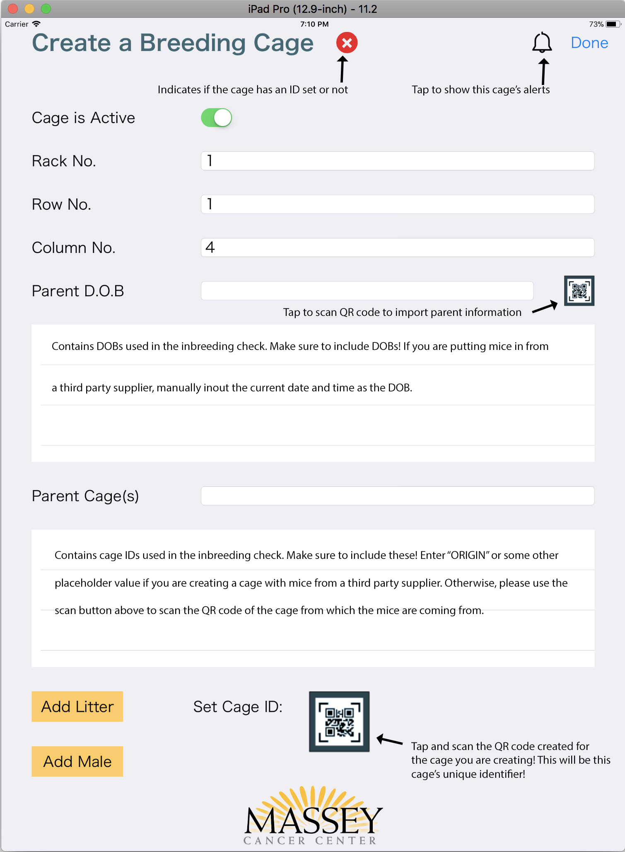

**Stock Cage View:**

Overview:

This view will display the information of any selected stock cage.

Creating New Stock Cages:

When creating a new cage, the application will automatically fill in the “Cage is Active”, rack number, row number, and column number sections for you. All pieces of information can be set/manipulated when creating a new stock cage. Below is an image depicting the function of each button/indicator/text field/table visible in this view.

Modifying an Existing Stock Cages:

When modifying an existing stock cage everything can be updated except for the following: Set Cage ID button, alerts. Alerts can be resolved by completing the necessary action the alert is informing you about. For example, if you have a “Wean Cage” alert, you will need to wean the specified cage and the alert will be automatically removed by the database at the end of the day. Click “Done” and select “Save and Continue” to retain any changes made.

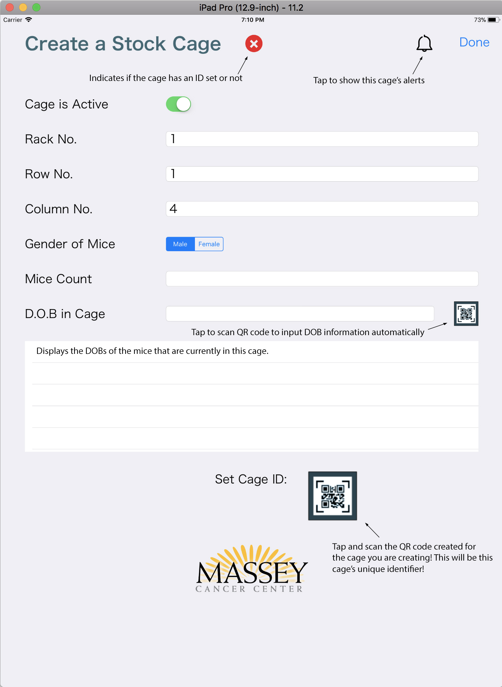

**Breeding Male View:**

Overview:

This view will display the information of any selected breeding male.

Creating New Breeding Males:

When creating a new breeding male, the application will automatically fill in the “Male is Active”, rack number, row number, and column number sections for you. All pieces of information can be set/manipulated when creating a new breeding male. Below is an image depicting the function of each button/indicator/text field/table visible in this view.

Modifying an Existing Breeding Males:

When modifying an existing breeding male everything can be updated except for the following: Set Cage ID button, alerts. Alerts can be resolved by completing the necessary action the alert is informing you about. For example, if you have a “Wean Cage” alert, you will need to wean the specified cage and the alert will be automatically removed by the database at the end of the day. Click “Done” and select “Save and Continue” to retain any changes made.

Moving Breeding Males to A New Cage:

View a breeding male, either by scanning the males QR code from the main menu, or by navigating to a breeding cage and viewing the male within. Then tap the “Scan QR Code” button that is located to the right of the “Current Cage Info” text field. The QR scanner view will appear, scan the QR code of the breeding cage you wish to move that male to. Confirm the changes by tapping the “Done” button at the top right-hand side of the breeding male view and select “Save and Continue”.

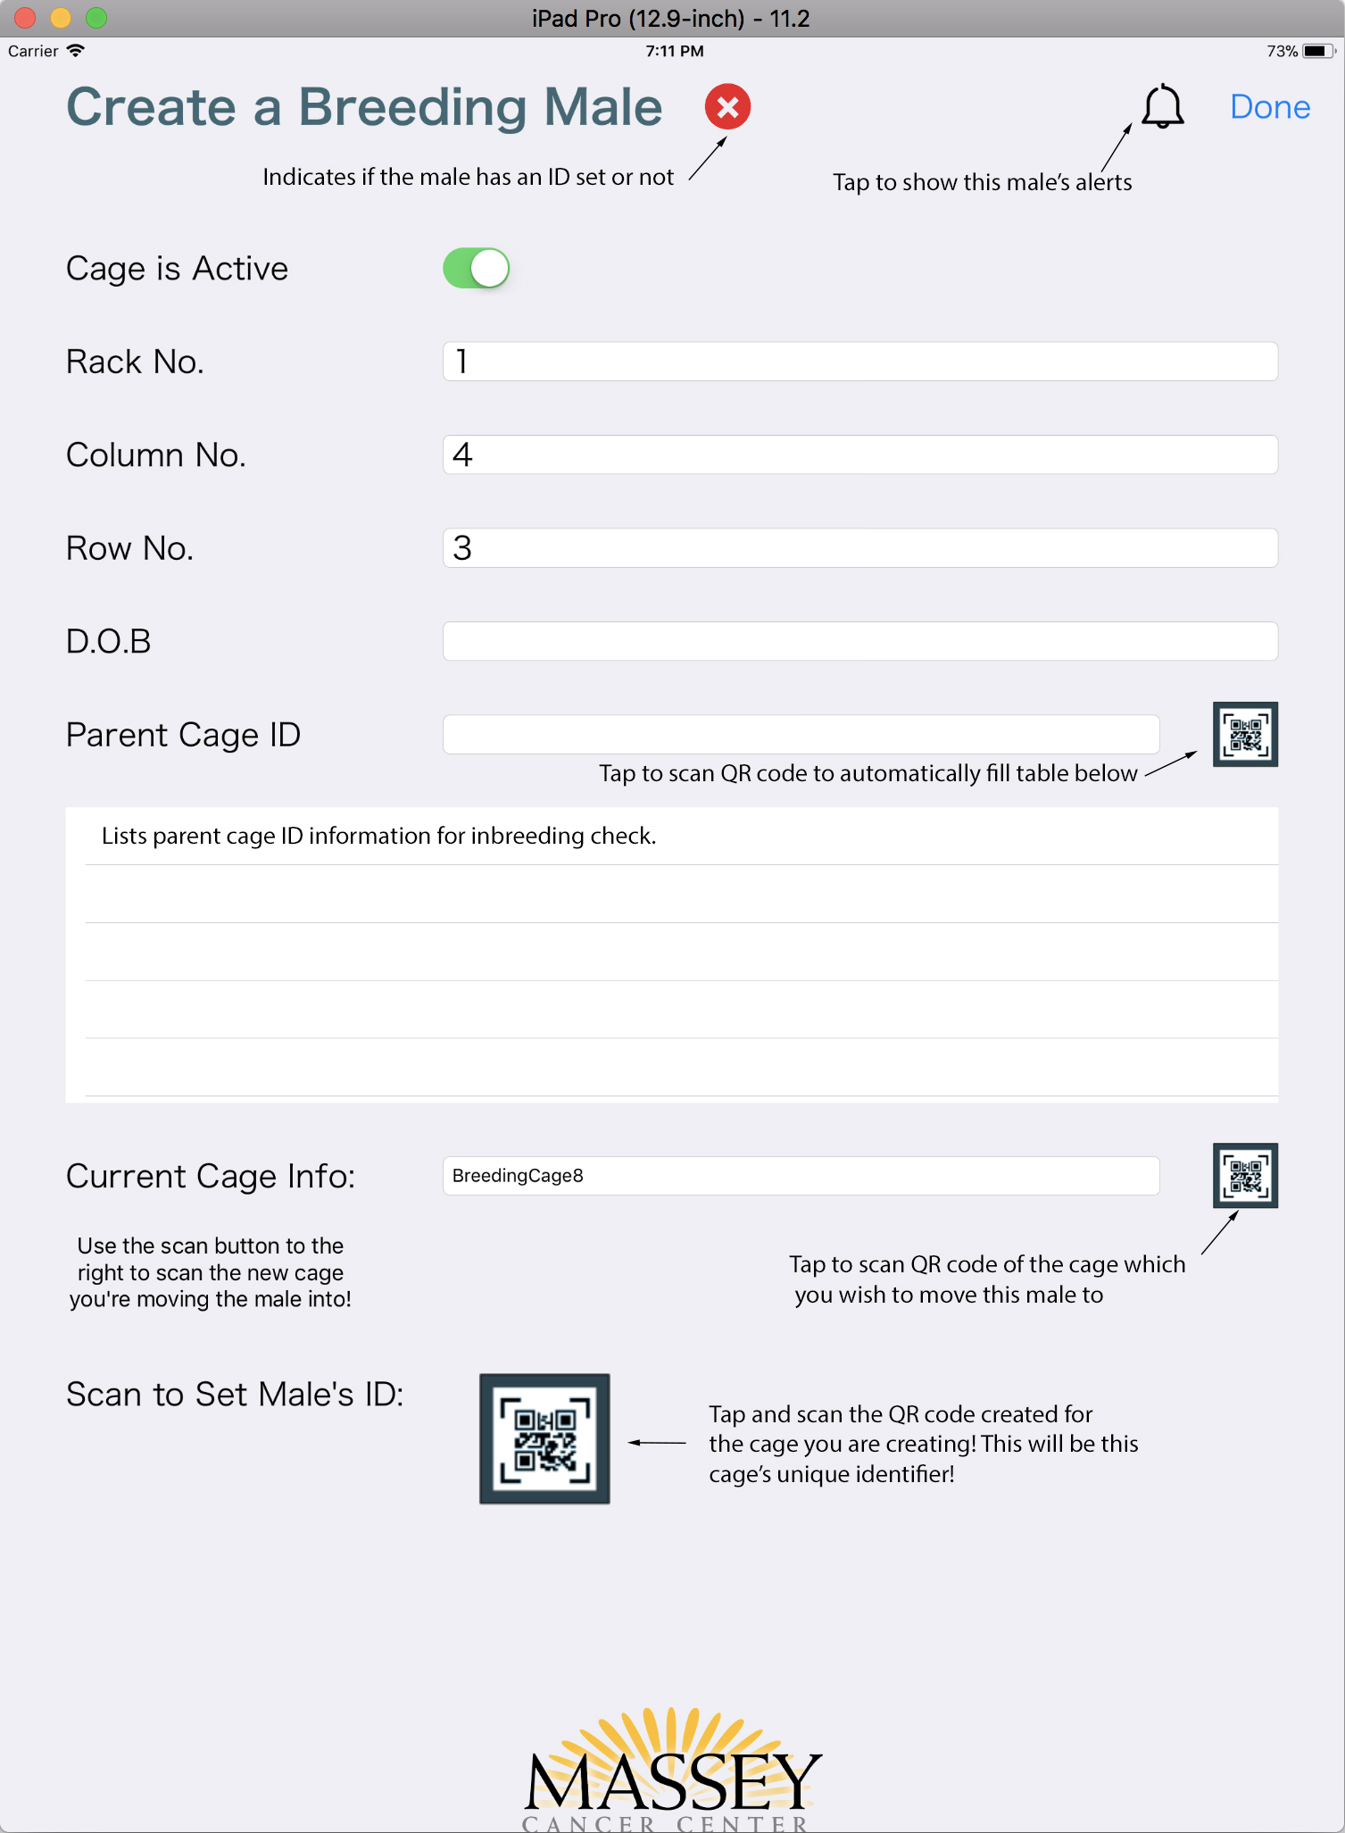

**Alerts View:**

Overview:

This view can be accessed from the menu on the rack view. This view displays a list of all alerts that are active on cages stored in the database. The “Show Alerts” button can be tapped to refresh the alerts being displayed. Note, alerts cannot be removed from this list! By swiping an alert to the left you are given the option of marking the selected alert as “Resolved.” This flag is only a visual one and does not actually mark the alert for removal at the end of the day. To resolve an alert, you must complete the action the alert is informing you of. To complete this action, you are able to tap on the alert within the Alerts View to view the cage/male that has the selected alert. Within the view that appears, perform the necessary action to resolve the alert (Below is an explanation of how to resolve each alert). At the end of the day, the database will automatically clear any alerts that have been resolved. In addition, should you mark an alert as “Resolved” in the alert view but wish to revert this flag, simply swipe left again on the desired alert marked “Resolved” to bring up the option to “Unresolve” the alert.

* + Any alert marked as “Resolved” or “Unresolved” can be seen within a cage/male view by tapping the Alert Bell icon in the top right hand corner.
* Alerts and how to resolve them…
  + Wean Cage:
    - Enter the cage that needs to be weaned, and tap the “Wean Cage” button in the bottom left. Press “Done” and select “Save and Continue” to retain changes.
  + Old Breeding Male:
    - Enter the cage or view the male via the alerts view with the ”Old Breeding Male” alert applied to it. Simply switch the “Active” switch from “On” to “Off”. Confirm the changes, and select “Done” and “Save and Continue” to retain changes.
  + Old Breeding Female:
    - Due to there being two females within a cage, and each not being individually identifiable, both females in most cases will need to be replaced. Simply mark the “Active” switch from “On” to “Off”.
      * Should you be able to determine which female is needing to be replaced but the other is not required to be removed, you will still have to deactivate the cage to have the database recognize the alert as resolved and to have it cleared. If you wish to keep the mouse that is not too old, you will have to create a new breeding cage with that mouse.
      * In addition, if the “Old Breeding Female” alert appear while a cage contains a litter. We would recommend you disregard the alert until the litter is ready to be weaned. Then wean the litter and deactivate the cage along with its female(s).
  + Cage with Order:
    - To resolve this alert, deactivate the cage upon removing it from the rack for distribution to the buyer.

**Scan QR Code View:**

Overview:

This view will display the QR code scanner. Note, to use this view the application requires permission to access your device’s camera! Once the view has appeared, place your device so that the QR code you wish to can is in view. The application will place a green border around a QR code that it recognizes. Tap the “Confirm Code” button on the bottom right-hand corner of the screen to confirm it has recognized the QR code you wish to scan! The application will then attempt to retrieve the appropriate mouse’s information that corresponds with the scanned QR code. If there is no mouse with the scanned QR code, then the application will display an error.

**Settings View:**

Overview:

This view will display the settings that are shared across all devices running this application. All settings are modifiable. Tap the “Done” button in the top right-hand corner of the view and select “Save and Continue” to retain any changes made. If there is more than one device currently running the application at the same time you have edited the settings, make sure the other devices tap the “Refresh View” button on the Rack View to apply the changes made.